Cameron Stewart

Mini Project 4 MongoDB

Use MongoDB as a DB to Sales Order DB or any other sample data that you want to use. Use Compass to connect to the MongoDB and insert, update and query data from MongoDB.

**Solution:**

I used the ‘Company’ Database from a previous project for this activity. My steps are listed below

1. Created Cluster
   1. 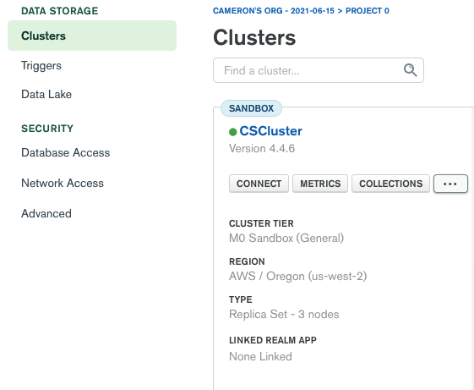
2. Connected Compass to MongoDB Cluster
   1. 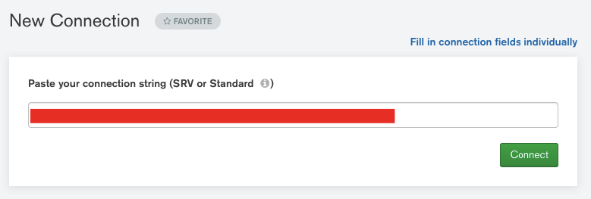
3. Created a Database and first Collection called Company
   1. 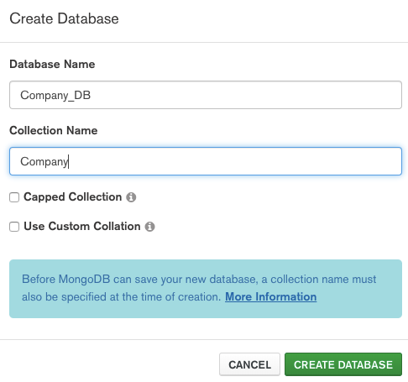
4. Download data from each table in ‘Company’ Database in MySQL Workbench to a CSV. Below, shows me doing this for the table Company from the database company. Tables transferred include Company, Employee, Manages, and Works.
   1. 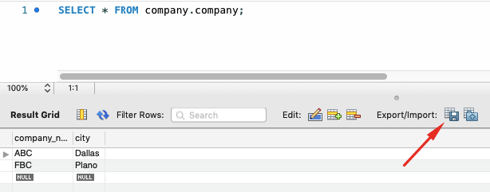
5. Import data into Collection ‘Company’ in the ‘Company_DB’ Database via the CSV. I will use this same process of creating a collection and importing data through a downloaded CSV for each collection.
   1. 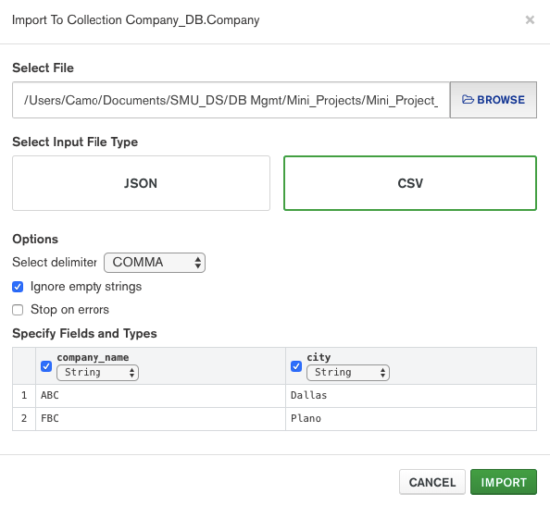
6. View completed migration of MySQL database to MongoDB
   1. 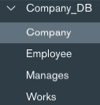
   2. 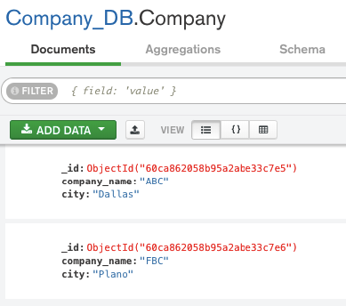
7. Insert a Document into Company Collection
   1. 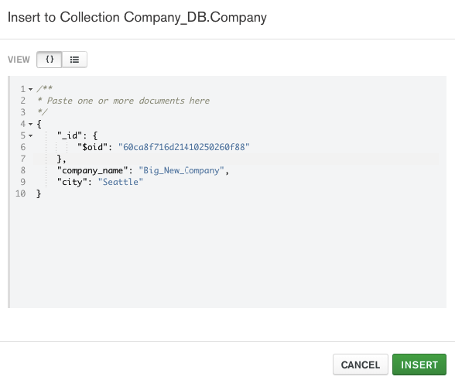
   2. 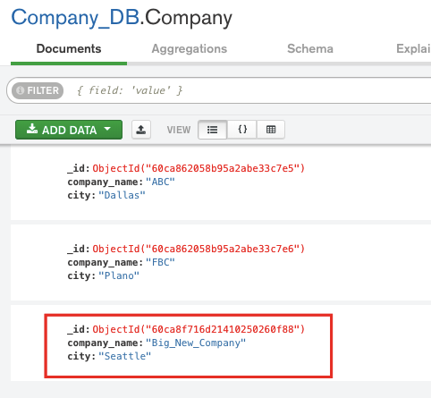
8. Update a document in Company Collection
   1. 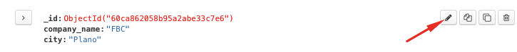
   2. 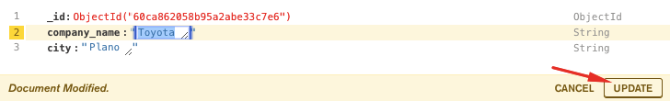
   3. 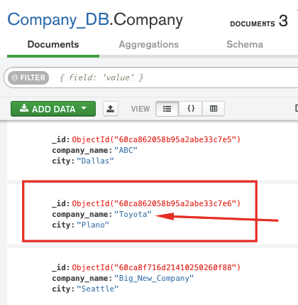
9. Query documents from Company_DB Database in Works collection. Query looks for documents where company_name = “ABC” and then sorts in ascending order by person_name.
   1. 